Learning Outcome

Laravel Framework

(45 Hours)

## 

# Introduction to MVC Architecture

## What is MVC Framework

The Model-View-Controller (MVC) framework is an architectural pattern that separates an application into three main logical components Model, View, and Controller. Hence the abbreviation MVC. Each architecture component is built to handle specific development aspect of an application. MVC separates the business logic and presentation layer from each other. It was traditionally used for desktop graphical user interfaces (GUIs). Nowadays, MVC architecture in web technology has become popular for designing web applications as well as mobile apps.

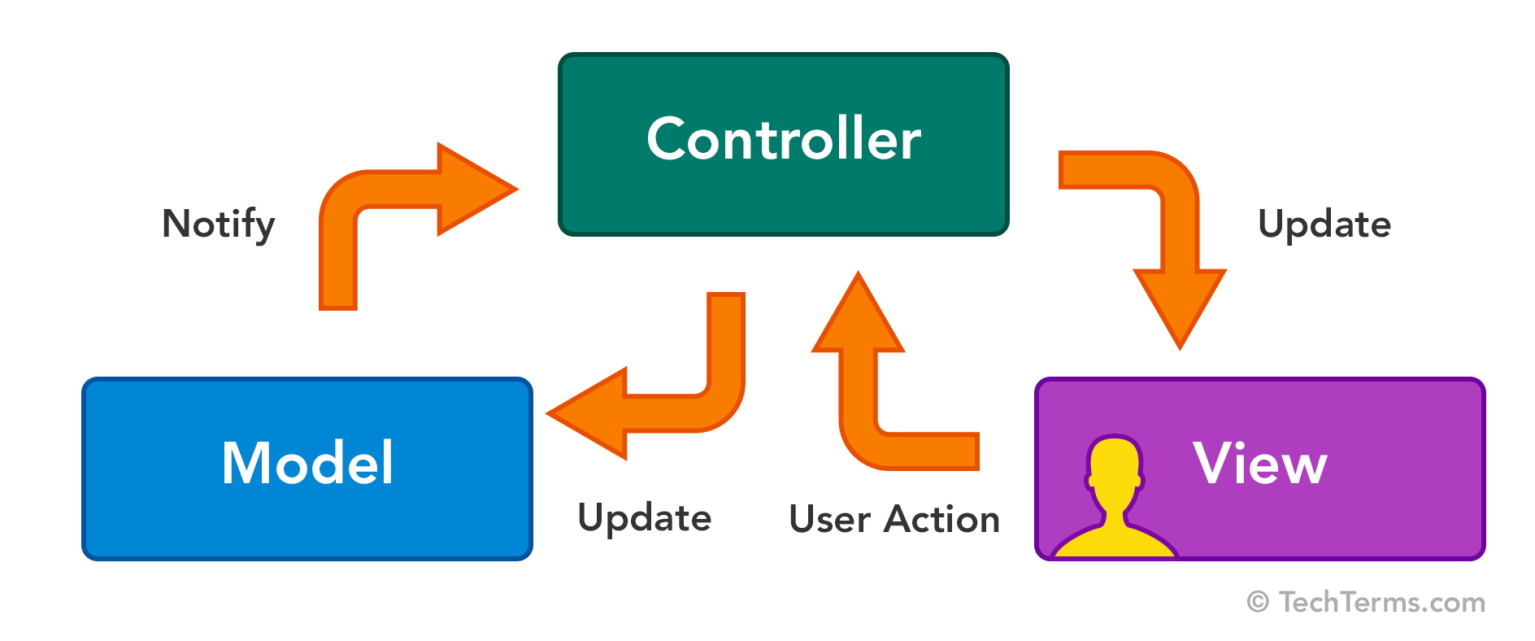

Image: MVC Framework

Reference: <https://techterms.com/img/lg/mvc_1321.png>

## History of MVC

Trygve Reenskaug invented MVC. The first reports on MVC were written when he was visiting a scientist at Xerox Palo Alto Research Laboratory (PARC) in 1978/79. At first, MVC was called “Thing Model View Editor” but rapidly changed it to “ Model View Controller”.

The goal of Tygrve was to solve the problem of users controlling a large and complex data set. The practice of MVC has changed over the years. Sinces the MVC pattern was invented before web browsers, initially was used as an architectural pattern for graphical user interfaces(GUI).

Currently MVC it’s used for designing web applications. Some web frameworks that use MVC concept: Ruby on Rails, Laravel, Zend framework, CherryPy, Symphony, etc

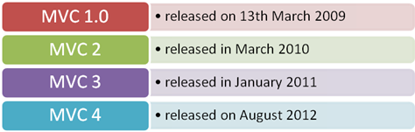

Image : History of MVC

Reference: <https://www.codeproject.com/KB/aspnet/669195/image001.png>

## Features of MVC

* Easy and frictionless testability. Highly testable, extensible and pluggable framework
* To design a web application architecture using the MVC pattern, it offers full control over your HTML as well as your URLs
* Leverage existing features provided by ASP.NET, JSP, Django, etc.
* Clear separation of logic: Model, View, Controller. Separation of application tasks viz. business logic, Ul logic, and input logic
* URL Routing for SEO Friendly URLs. Powerful URL- mapping for comprehensible and searchable URLs
* Supports for Test Driven Development (TDD)



Image 1: Features of MVC

Reference: <https://docs.microsoft.com/en-us/aspnet/mvc/overview/older-versions-1/overview/asp-net-mvc-overview/_static/image1.jpg>

## MVC Architecture

MVC is an architectural pattern which means it rules the whole architecture of the applications. Even though often it is known as design pattern but we may be wrong if we refer it only as a design pattern because design patterns are used to solve a specific technical problem, whereas architecture pattern is used for solving architectural problems, so it affects the entire architecture of our application.

Three important MVC components are:

* Model: It includes all the data and its related logic
* View: Present data to the user or handles user interaction
* Controller: An interface between Model and View components

and each of them has specific responsibilities.

The main reasons why MVC is used are: First, it doesn't allow us to repeat ourselves and second, it helps to create a solid structure of our web applications.

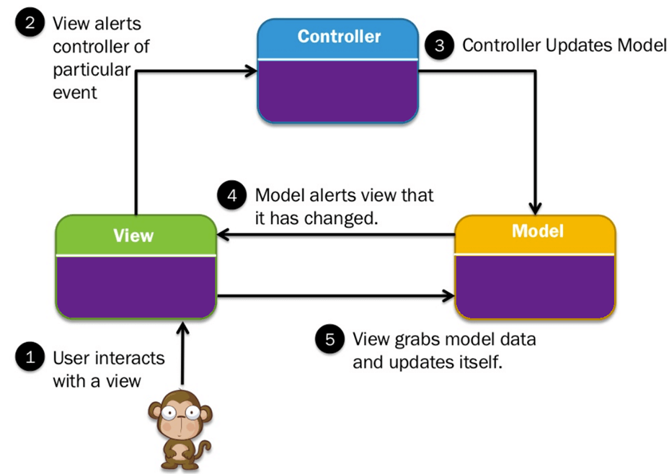

Image : MVC Architecture

Reference: <https://www.guru99.com/images/1/122118_0445_MVCTutorial1.png>

### Model

It is known as the lowest level which means it is responsible for maintaining data. Handle data logically so it basically deals with data. The model is actually connected to the database so anything you do with data. Adding or retrieving data is done in the model component. It responds to the controller requests because the controller never talks to the database by itself. The model talks to the database back and forth and then it gives the needed data to the controller. Note: the model never communicated with the view directly.

### View

Data representation is done by the view component. It actually generates UI or user interface for the user. So at web applications when you think of the view component just think the Html/CSS part. Views are created by the data which is collected by the model component but these data aren’t taken directly but through the controller, so the view only speaks to the controller.

### Controller

It’s known as the main man because the controller is the component that enables the interconnection between the views and the model so it acts as an intermediary. The controller doesn’t have to worry about handling data logic, it just tells the model what to do. After receiving data from the model it processes it and then it takes all that information it sends it to the view and explains how to represent to the user. Note: Views and models can not talk directly.

## Advantages of MVC

* MVC architecture will separate the user interface from business logic and business logic
* Components are reusable.
* Easy to maintain.
* Different components of the application in MVC can be independently deployed and maintained.
* This architecture help to test components independently.

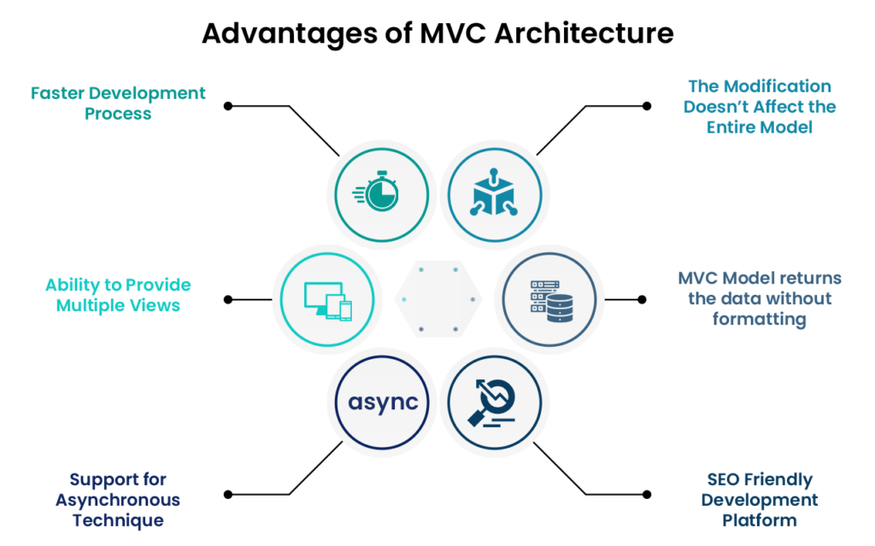

Image : Advantages of MVC

Reference: <https://shreysharma.com/wp-content/uploads/2021/05/Advantages-of-MVC-1024x639.png>

## Disadvantages of MVC

* The complexity is high.
* Not suitable for small applications.
* The inefficiency of data access in view.

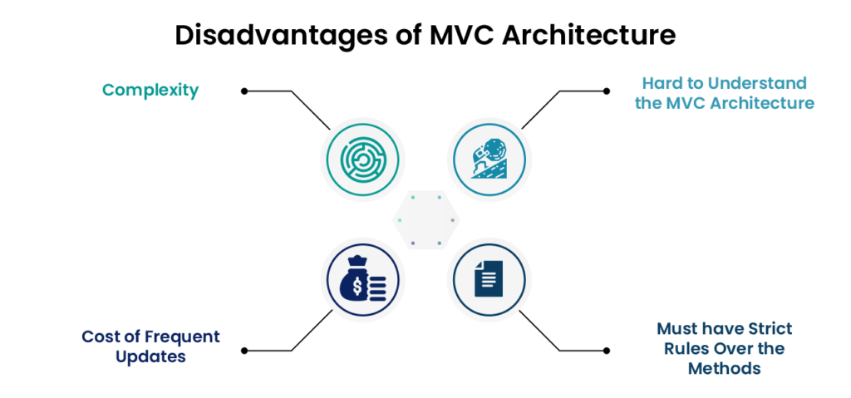

Image : Disadvantages of MVC

Reference: <https://shreysharma.com/wp-content/uploads/2021/05/Disadvantage-of-MVC-1024x479.png>

## MVC Example

Let’s see Model View Controller example from daily life:

### Example 1

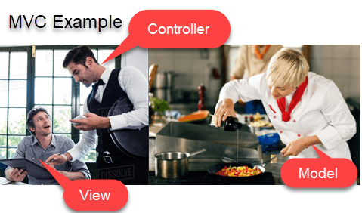

Image : MVC Example

Reference: <https://www.guru99.com/images/1/122118_0445_MVCTutorial2.png>

* Let’s assume you go to a restaurant. You will not go to the kitchen and prepare food which you can surely do at your home. Instead, you go there and wait for the waiter to come on.
* Now the waiter comes to you, and you order the food. The waiter doesn’t know who you are and what you want he just written down the detail of your food order.
* Then, the waiter moves to the kitchen. In the kitchen, waiter does not prepare your food.
* The cook prepares your food. The waiter is given your order to him along with your table number.
* Cook then prepared food for you. He uses ingredients to cooks the food. Let’s assume that your order a vegetable sandwich. Then he needs bread, tomato, potato, capsicum, onion, bit, cheese, etc. which he sources from the refrigerator
* Cook final hand over the food to the waiter. Now it is the job of the waiter to moves this food outside the kitchen.
* Now waiter knows which food you have ordered and how they are served.

In this MVC architecture example,

View= You

Waiter= Controller

Cook= Model

Refrigerator= Data

Let see one more MVC model example,

### Example 2

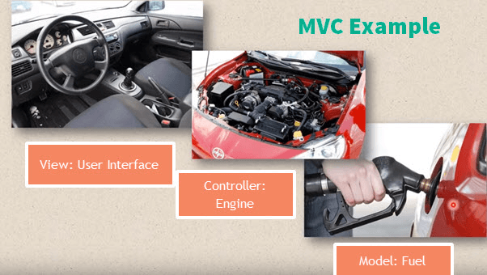

Image : MVC Example

Reference: <https://www.guru99.com/images/1/122118_0445_MVCTutorial3.png>

Car driving mechanism is another example of the MVC model.

* Every car consists of three main parts.

View= User interface : (Gear lever, panels, steering wheel, brake, etc.)

Controller- Mechanism (Engine)

Model- Storage (Petrol or Diesel tank)

Car runs from engine take fuel from storage, but it runs only using mentioned user interface devices.

## Popular MVC web frameworks

Here, is a list of some popular MVC frameworks:

* Ruby on Rails
* Django
* CakePHP
* Yii
* CherryPy
* Spring MVC
* Catalyst
* Rails
* Zend Framework
* CodeIgniter
* Laravel
* Fuel PHP
* Symphony

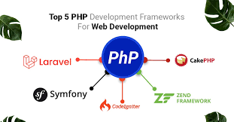

Image : Popular MVC web framework

Reference: <https://encrypted-tbn0.gstatic.com/images?q=tbn:ANd9GcSn90IPA7GwIM2vnme_AImycQswV1OPiIq2GJ-Nm6bx3aMRKjwFak_wmpIGIiRtTYRBXYU&usqp=CAU>

# What is Framework and its Benefits

## Introduction to a Framework

Since they are often built, tested, and optimized by several experienced software engineers and programmers, software frameworks are versatile, robust, and efficient.

Using a software framework to develop applications lets you focus on the high-level functionality of the application. This is because any low-level functionality is taken care of by the framework itself.

## Why do we use Frameworks?

Developing software is a complex process. It necessitates a plethora of tasks, including coding, designing, and testing. For only the coding part, programmers had to take care of the syntax, declarations, garbage collection, statements, exceptions, and more.

Software frameworks make life easier for developers by allowing them to take control of the entire software development process, or most of it, from a single platform.

Advantages of using a software framework:

* Assists in establishing better programming practices and fitting use of design patterns
* Code is more secure
* Duplicate and redundant code can be avoided
* Helps consistent developing code with fewer bugs
* Makes it easier to work on sophisticated technologies
* One could create their software framework or contribute to open-source frameworks. Hence, there is a continuous improvement in the functionality
* Several code segments and functionalities are pre-built and pre-tested. This makes applications more reliable
* Testing and debugging the code is a lot easier and can be done even by developers who do not own the code
* The time required to develop an application is reduced significantly

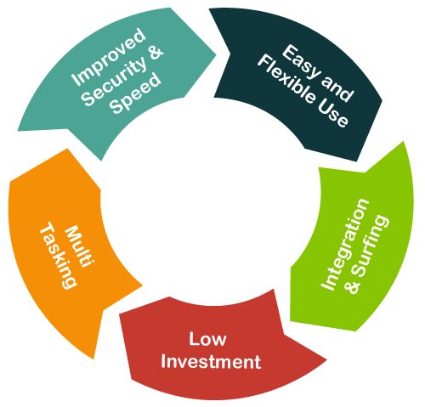

Image : Introduction to a framework

Reference: <https://static.javatpoint.com/tutorial/vb-net/images/vb-net-dot-net-framework-introduction2.png>

## What goes in a Framework?

When you install a software framework, the first thing that you need to take care of is the system requirements. Once a framework is installed and configured, it creates a directory structure.

For example, Image shown the directory structure of the Laravel Framework. Each of these folders could have additional directories. Directories can further have files, classes, test routines, templates, and more.

## Difference between a Library and a Framework

Some may assume that a software framework is a collection of libraries just as libraries are a collection of precompiled routines. However, this is not true as not all software frameworks use or depend on libraries.

The difference between a library and a framework is that the latter calls the code. Opposite to this, the code calls the software library. Let us understand this with an example:

curl is a library in PHP. When you use one of the curl functions, the PHP code calls that particular function in the curl library. Your code is the caller, and the library code is the callee.When you use a PHP framework, such as Laravel, the relationship gets inverted, and so the software framework calls the application code written in the framework. This is technically known as Inversion of Control (IoC).

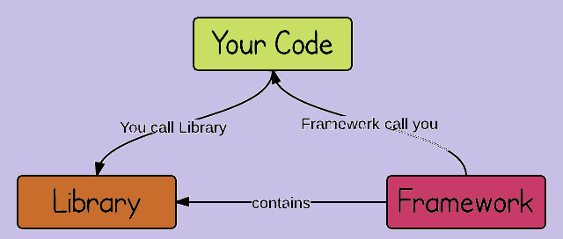

Image : Difference between a Library and a Framework

Reference: <https://csharpcorner-mindcrackerinc.netdna-ssl.com/UploadFile/a85b23/framework-vs-library/Images/DqCkT.png>

## Programming language vs Frameworks

A programming language tells the computer what it should do. Every programming language features a syntax and a particular set of rules, which need to be followed every time the code is written. A software framework is built on top of a programming language. For example,

Rails, also known as Ruby on Rails, is a web framework built on top of the Ruby programming language.

Django and Flask are two different web frameworks built on top of the Python programming language. Hence, they are also known as Python frameworks. React, and Angular are front-end web frameworks built on top of the JavaScript programming language.

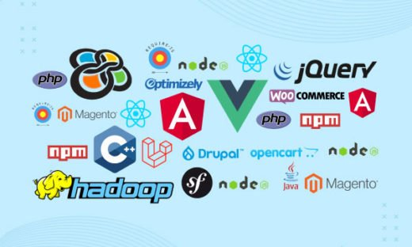

Image : Programming language vs Frameworks

Reference: <https://www.netsolutions.com/insights/wp-content/uploads/2021/10/what-is-a-framework-in-programming-and-why-you-should-choose-one-520x312.jpg>

## Types of Frameworks

As a developer, you should be on the lookout for frameworks that best suit your needs. Whether it is working on a website, data science, database management, or mobile applications, software frameworks exist for all genres of software programming.

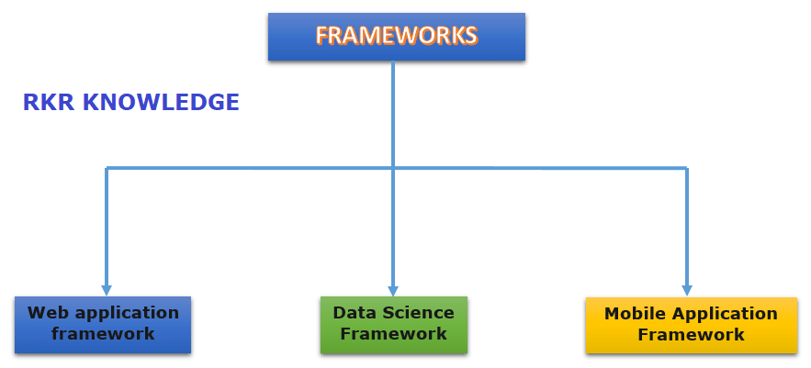

Image : Types of framework

Reference: <https://rkrknowledge.com/wp-content/uploads/2020/09/Screenshot-11.png>

There are many types of software frameworks to make it easier for developing applications for a wide range of application development domains. Let us dive into some of the software frameworks that are in vogue today:

### Web Application Frameworks

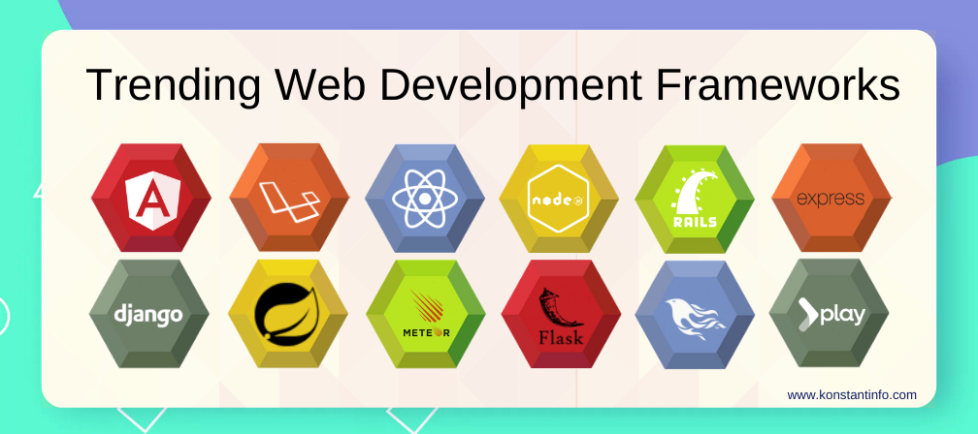

Image : Web Application Frameworks

Reference: <https://www.konstantinfo.com/blog/wp-content/themes/konstantinfo/imageC.php?image=/2018/07/web-development-frameworks-2020.png>

#### Angular

Angular is a typescript-based, open-source JS framework that makes it easy to build applications on the web. Angular solves application development challenges by combining declarative templates, dependency injection, end-to-end tooling, and much more.

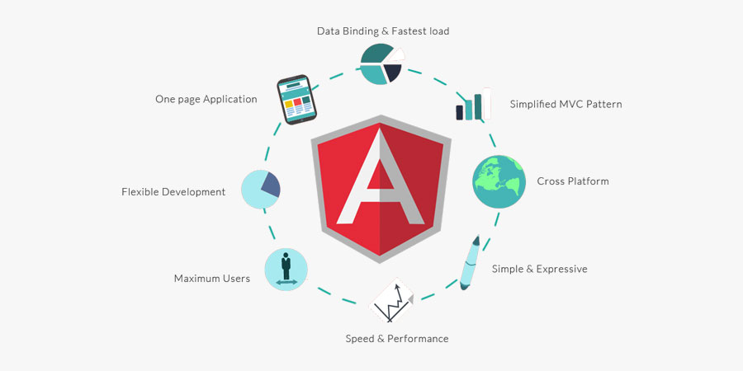

Image : Angular

Reference: <https://www.etatvasoft.com/blog/wp-content/uploads/2017/01/b-thumb-img12.jpg>

Some popular websites developed using AngularJS are:

* Netflix
* Paypal
* Upwork
* Youtube
* Django

#### Laravel

Laravel is a PHP-based web application framework with an expressive, elegant syntax. The open-source framework and follows a model-view-controller design pattern that is robust and easy to understand.

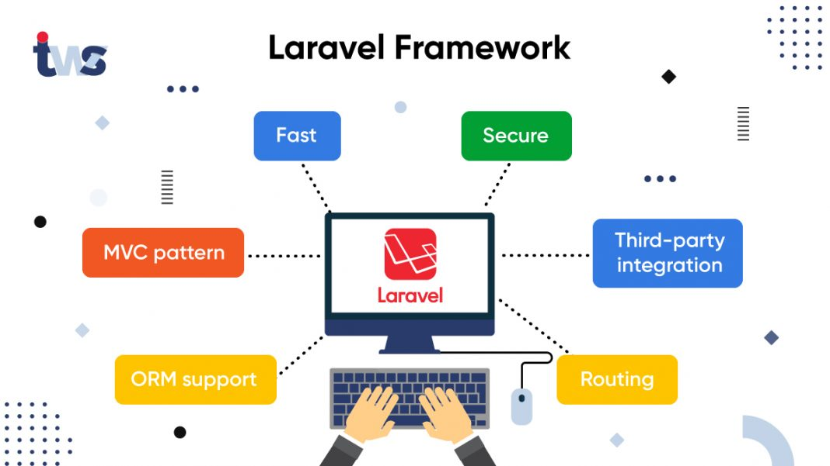

Image : Laravel

Reference: <https://www.tekkiwebsolutions.com/wp-content/uploads/Laravel-Framework-banner.jpg>

Some popular websites developed using Laravel are:

* Alison.com
* Barchart.com
* Neighborhood Lender
* World Walking

### DataScience Frameworks

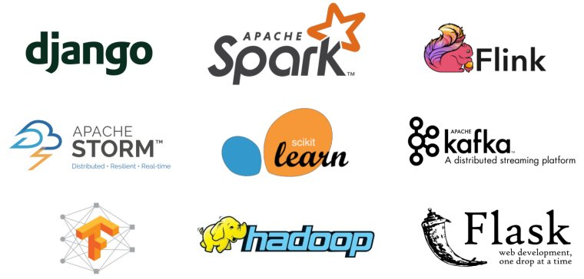

Image : DataScience Framework

Reference: <https://wonderfulengineering.com/wp-content/uploads/2018/09/Data-science-frameworks-1.jpg>

#### Apache Spark

Apache Spark is a unified analytics engine for large-scale data processing. You can write applications quickly in Java, Scala, Python, R, and SQL using the Apache Spark.

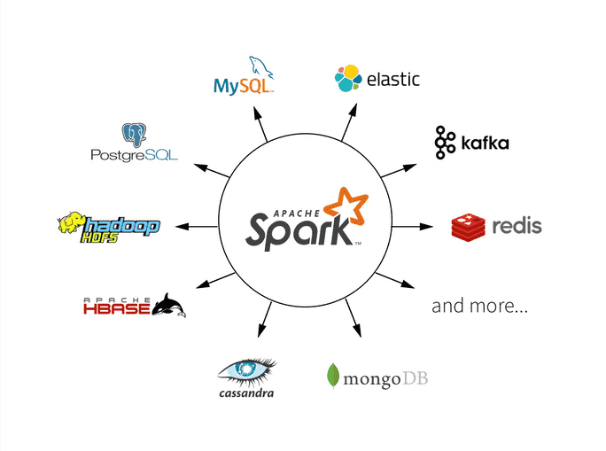

Image : Apache Spark

Reference: <https://databricks.com/wp-content/uploads/2019/02/largest-open-source-apache-spark.png>

Over 3,000 companies are using Apache Spark, including top players like:

* Amazon
* Cisco
* Databricks
* Hortonworks
* Microsoft
* Oracle
* Verizon
* Visa

#### PyTorch

PyTorch is an open-source machine learning framework that accelerates the process from research and prototyping to production deployment. Primarily developed by Facebook’s AI research group, PyTorch can be used with Python as well as C++. PyTorch is used for Computer Vision and Natural Language Processing (NLP).

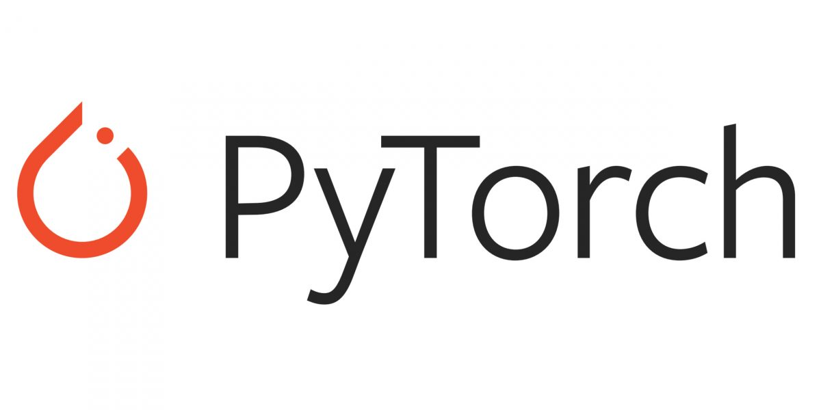

Image : PyTorch

Reference: <https://venturebeat.com/wp-content/uploads/2019/06/pytorch-e1576624094357.jpg?w=1200&strip=all>

Some popular websites developed using PyTorch are:

* Comcast
* Exelon
* Trifo
* Quadient

#### TensorFlow

TensorFlow is an end-to-end open-source framework for machine learning (ML). It has a comprehensive, flexible ecosystem of tools, libraries, and community resources that lets researchers dive in ML, and developers quickly build and deploy ML-powered applications.

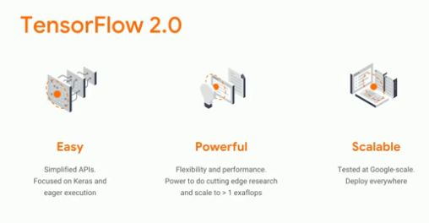

Image : TensorFlow

Reference: <https://csharpcorner-mindcrackerinc.netdna-ssl.com/article/what-is-new-in-tensorflow-2-0/Images/TensorFlow%202.0.jpg>

Three typical applications for TensorFlow are-

* Convolutional Neural Networks (CNN) for image recognition and processing.
* Large-scale linear models for data analysis and simple behavioral predictions.
* Sequence-to-Sequence (Seq2Seq) models for human language-related features.

### Mobile Development Frameworks

#### Ionic

Ionic is a free, open-source mobile UI toolkit for developing high-quality, cross-platform native applications for Android, iOS, and the Web—all from a single codebase. Ionic is a development platform for the entire application lifecycle that allows teams to build better and faster applications.

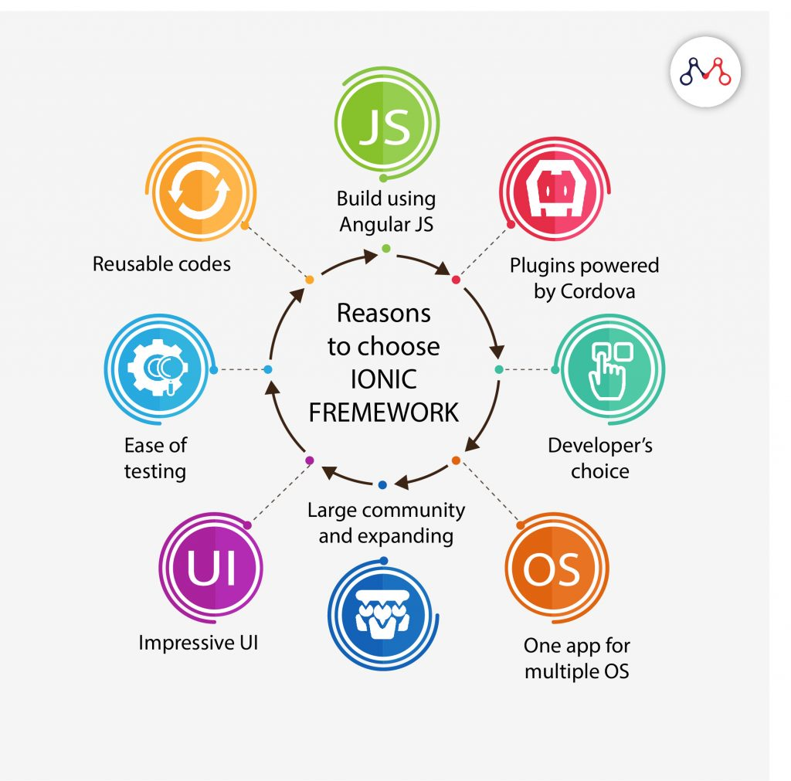

Image : Ionic

Reference: <https://www.mantralabsglobal.com/wp-content/uploads/2020/01/Reasons-to-choose-Ionic-Framework-1024x1011.jpg>

Some of the popular applications developed using Ionic are:

* MarketWatch
* McDonald's Türkiye
* Pacifica

#### Xamarin

Xamarin is a free, open-source application development platform for building Android, iOS applications with .NET, and C#. Xamarin is part of the .NET platform that has an active community of over 60,000 contributors from more than 3,700 companies.

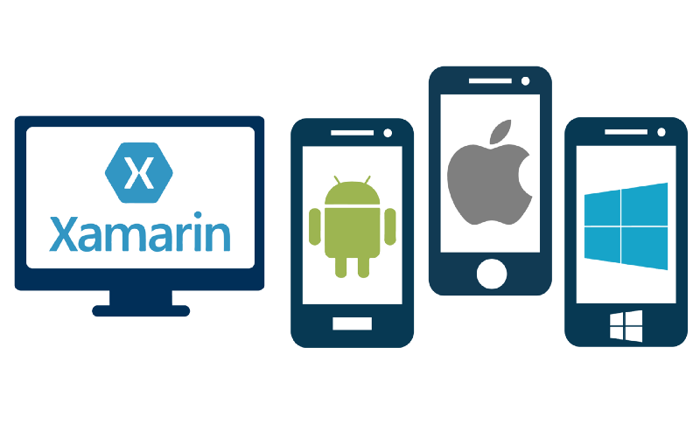

Image : Xamarin

Reference: [https://miro.medium.com/max/800/1*_asjrfF-MuyygNMH3bx6rg.png](https://miro.medium.com/max/800/1*_asjrfF-MuyygNMH3bx6rg.png)

Some of the popular applications developed using Xamarin are:

* Alaska airlines customer applications
* CA Mobile for mobile banking
* Novarum DX, a medical app

#### Flutter

Flutter is Google’s UI toolkit for building beautiful, natively compiled applications for mobile, web, and desktop from a single codebase. It has an expressive and flexible UI and gives a native performance on iOS and Android platforms.

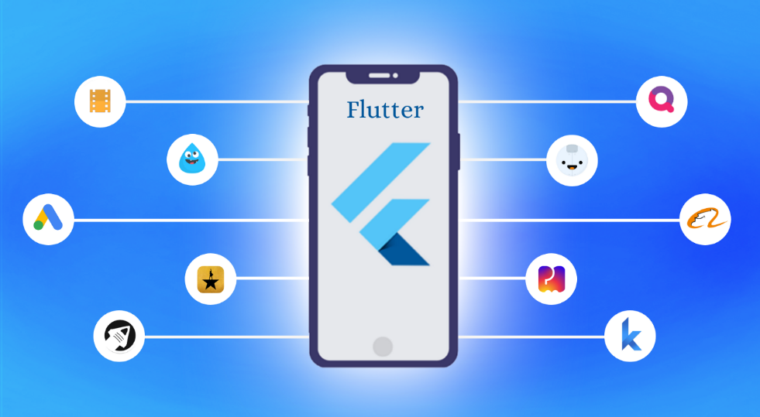

Image : Flutter Framework

Reference: [https://miro.medium.com/max/1400/1*-6WdIcd88w3pfphHOYln3Q.png](https://miro.medium.com/max/1400/1*-6WdIcd88w3pfphHOYln3Q.png)

Some of the popular applications developed using Flutter are:

* Alibaba (eCommerce)
* Cryptography
* Google Ads(utility)

# Laravel and its architecture

## What is Laravel

Laravel is a web application framework with expressive, elegant syntax. A web framework provides a structure and starting point for creating your application, allowing you to focus on creating something amazing while we sweat the details.

The Laravel Framework was developed by Taylor Otwell and released to the public in the year 2011.

Laravel strives to provide an amazing developer experience while providing powerful features such as thorough dependency injection, an expressive database abstraction layer, queues and scheduled jobs, unit and integration testing, and more.

Whether you are new to PHP or web frameworks or have years of experience, Laravel is a framework that can grow with you. We'll help you take your first steps as a web developer or give you a boost as you take your expertise to the next level. We can't wait to see what you build.

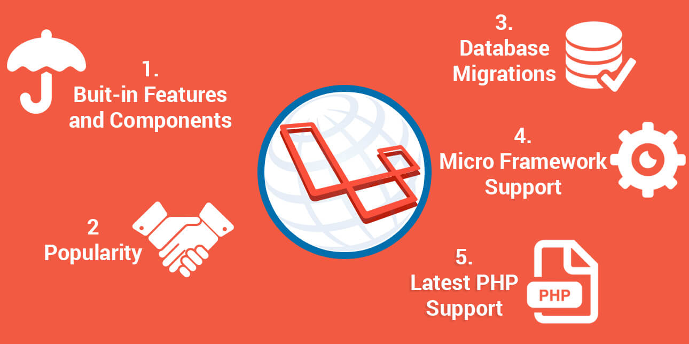

Image : What is Laravel

Reference: <https://www.mindinventory.com/blog/wp-content/uploads/2016/10/laravel.jpg>

## Why Laravel

There are a variety of tools and frameworks available to you when building a web application. However, we believe Laravel is the best choice for building modern, full-stack web applications.

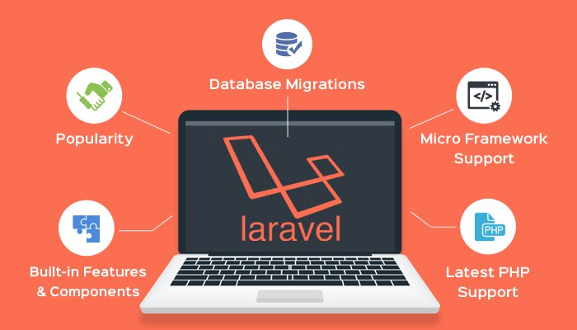

Image : Why Laravel

Reference: <https://res.cloudinary.com/jerrick/image/upload/v1623836011/60c9c56b8d2527001f049f1d.jpg>

### A Progressive Framework

We like to call Laravel a "progressive" framework. By that, we mean that Laravel grows with you. Laravel gives us robust tools for dependency injection, unit testing, queues, real-time events, and more. Laravel is fine-tuned for building professional web applications and ready to handle enterprise work loads.

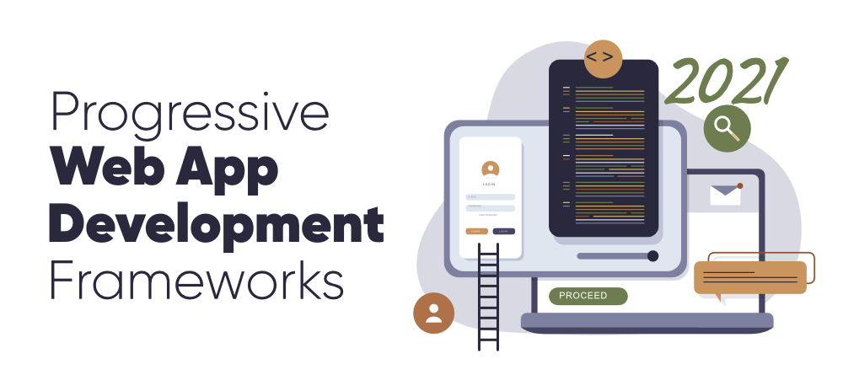

Image : A Progressive Framework

Reference: <https://media.geeksforgeeks.org/wp-content/cdn-uploads/20201218211223/7-Progressive-Web-App-Development-Frameworks-to-Know-in-2021.png>

### A Scalable Framework

Laravel is incredibly scalable. Thanks to the scaling-friendly nature of PHP and Laravel's built-in support for fast, distributed cache systems like Redis, horizontal scaling with Laravel is a breeze. In fact, Laravel applications have been easily scaled to handle hundreds of millions of requests per month.

Need extreme scaling? Platforms like Laravel Vapor allow you to run your Laravel application at nearly limitless scale on AWS's latest serverless technology.

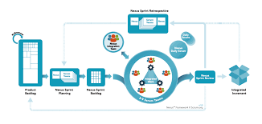

Image : A Sacalable Framework

Reference: <https://www.google.com/url?sa=i&url=https%3A%2F%2Fluis-goncalves.com%2Fwhy-safe-is-better-than-any-other-scalable-agile-framework%2F&psig=AOvVaw0x2q4ypfkuAMwuy-90Cawv&ust=1647067133006000&source=images&cd=vfe&ved=0CAsQjRxqFwoTCJj5t8K5vfYCFQAAAAAdAAAAABAD>

### A Community Framework

Laravel combines the best packages in the PHP ecosystem to offer the most robust and developer friendly framework available. In addition, thousands of talented developers from around the world have contributed to the framework. Who knows, maybe you'll even become a Laravel contributor.

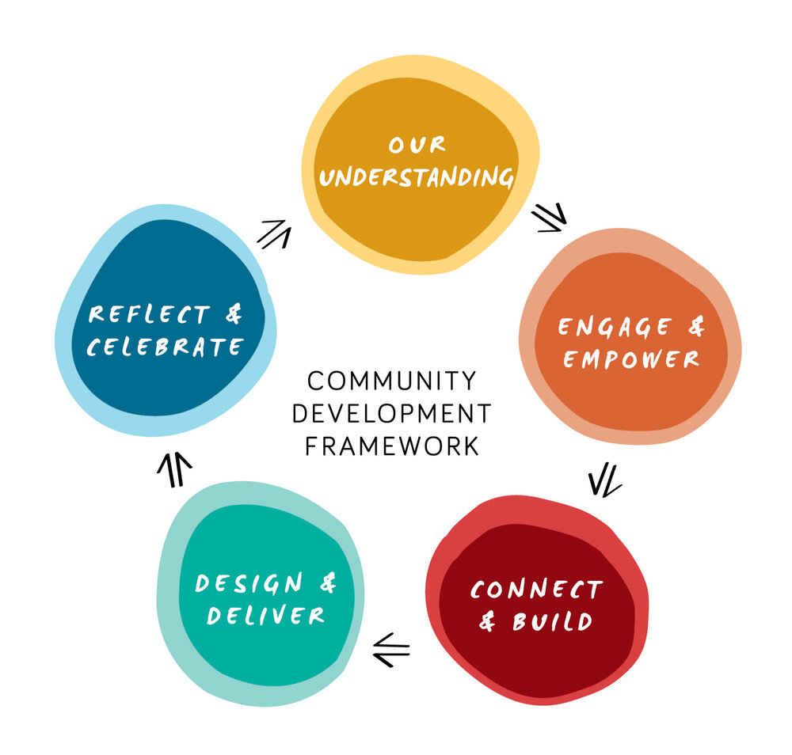

Image : A Community Framework

Reference: <https://images.squarespace-cdn.com/content/v1/5df6bf8c5a9fd4488885978d/1584659880828-RGUPD3N7KCCD4X601DWM/Community%2BDevelopment%2BFramework%2Bdiagram.jpg?format=1000w>

## MVC Architecture of Laravel

The Laravel Framework follows MVC architecture. MVC is an architectural design pattern that helps to develop web applications faster. MVC stands for Model-View-Controller.

* Model (M)–A model handles data used by the web application.
* View (V)–A view helps to display data to the user.
* Controller (C)–A controller interacts with the model to create data for the view.

The following image shows the interactions between Model, View, and Controller.

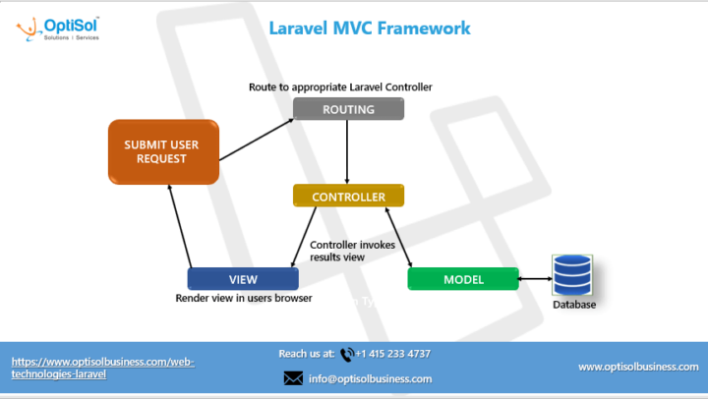

Image : MVC Architecture of Laravel

Reference: <https://www.optisolbusiness.com/wp-content/uploads/2020/02/Laravel_MVC_Infographic_OptiSol-thegem-blog-timeline-large.png>

### Pre-requisites For Laravel

Before proceeding further with this tutorial, you need to be familiar with the following concepts.

* HTML and CSS
* Core PHP and Advanced PHP
* Web application development using PHP and MySQL
* MVC architecture

## Install Laravel framework 8 for windows 10

### Install composer on Windows:

Follow below given steps to install composer on windows 10:

#### Step 1: Download Composer .exe File

In step 1, you need to open your browser and type getcomposer. Then visit on <www.getcomposer.org>. And download composer. If you already composer download / installed Composer. So, you need to move on next step.

Click Download Composer from <www.getcomposer.org>.

#### Step 2 – Run the setup and Install Composer

In step 2, click on download composer.exe file. Then open one prompt box :

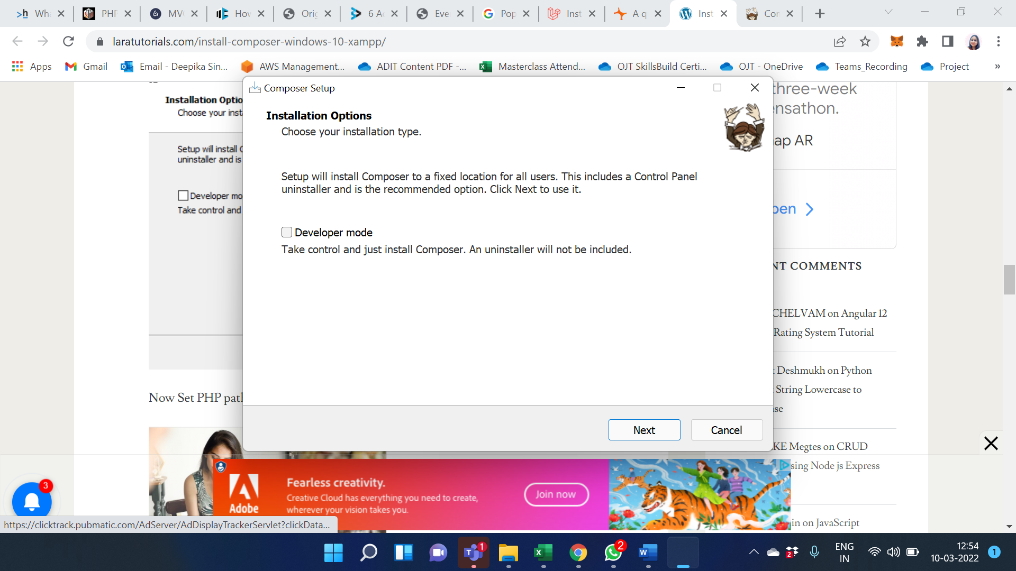

Now Set PHP path and click on next:

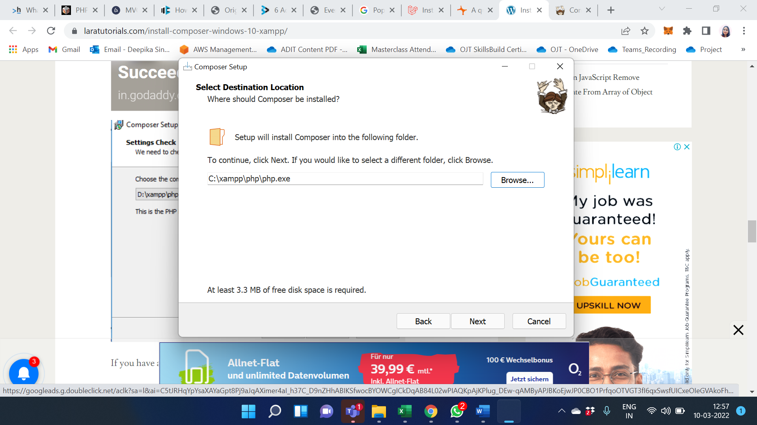

If you have any proxy URL enter here, don’t know to leave it to click next:

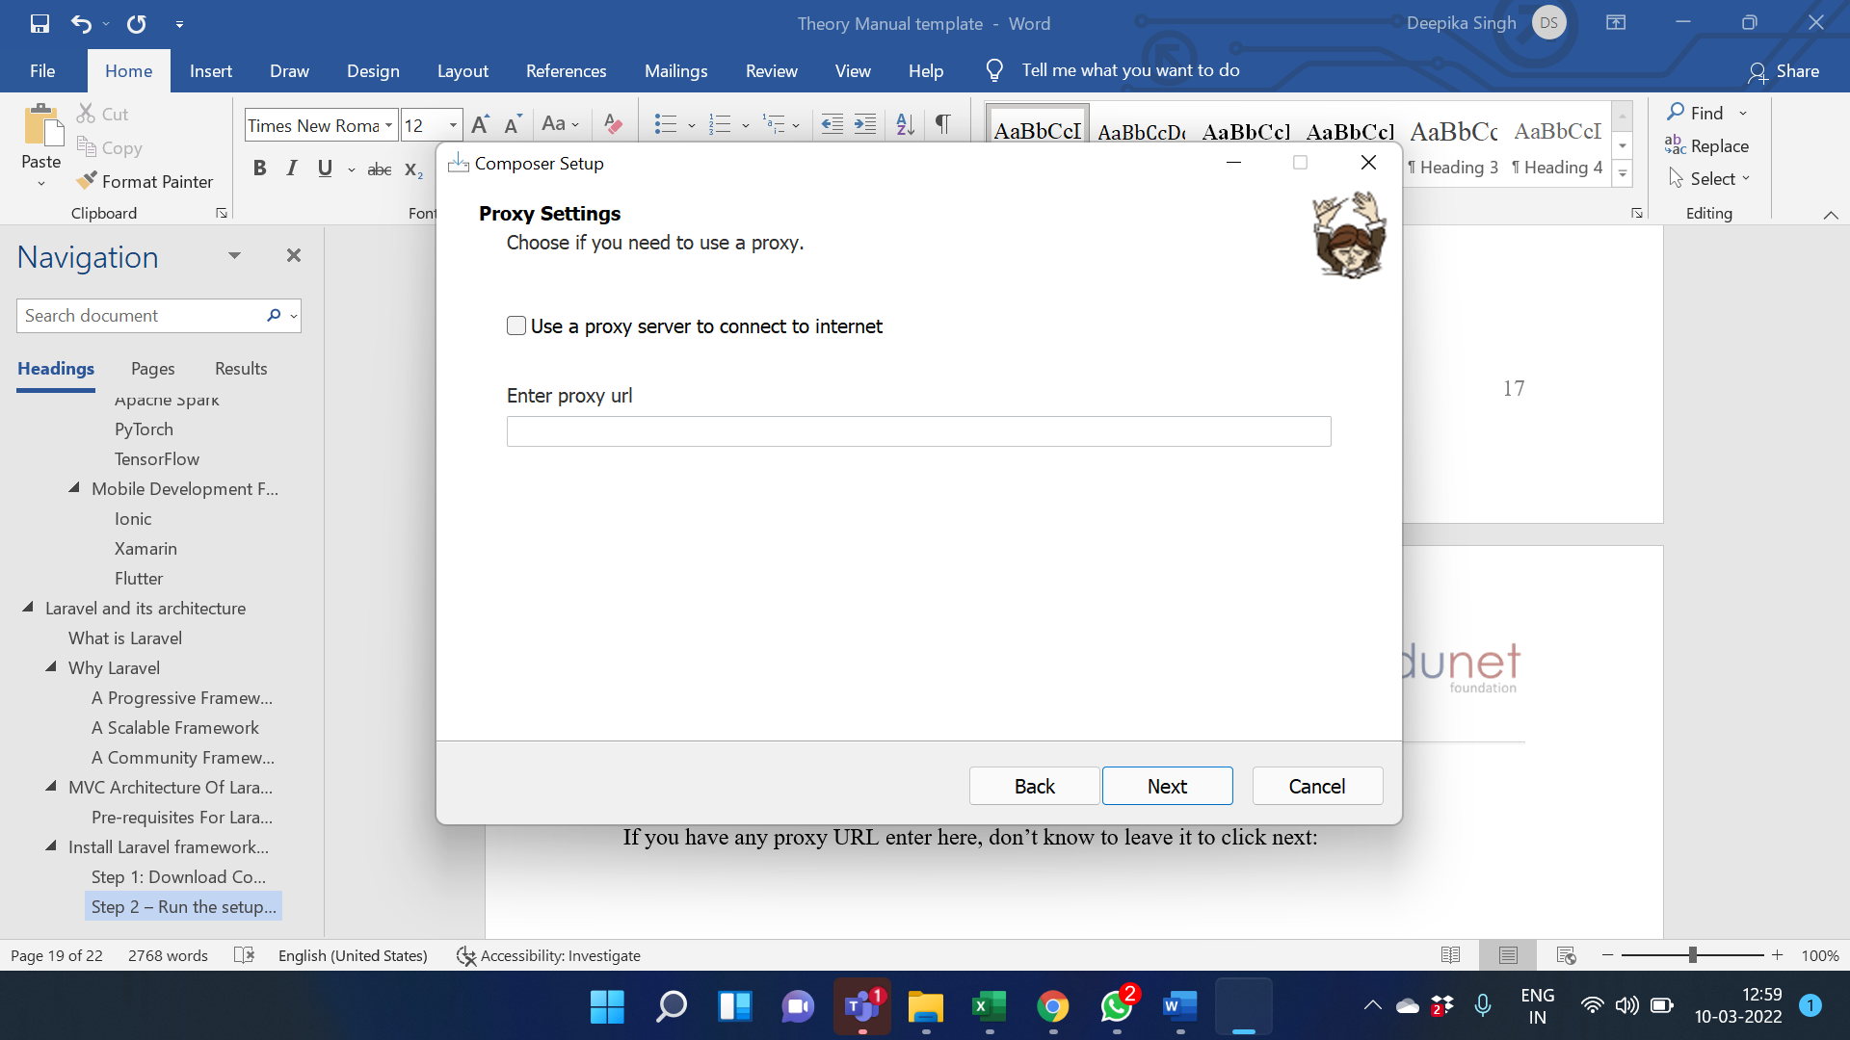

Now, review the composer setup wizard. And click on install.

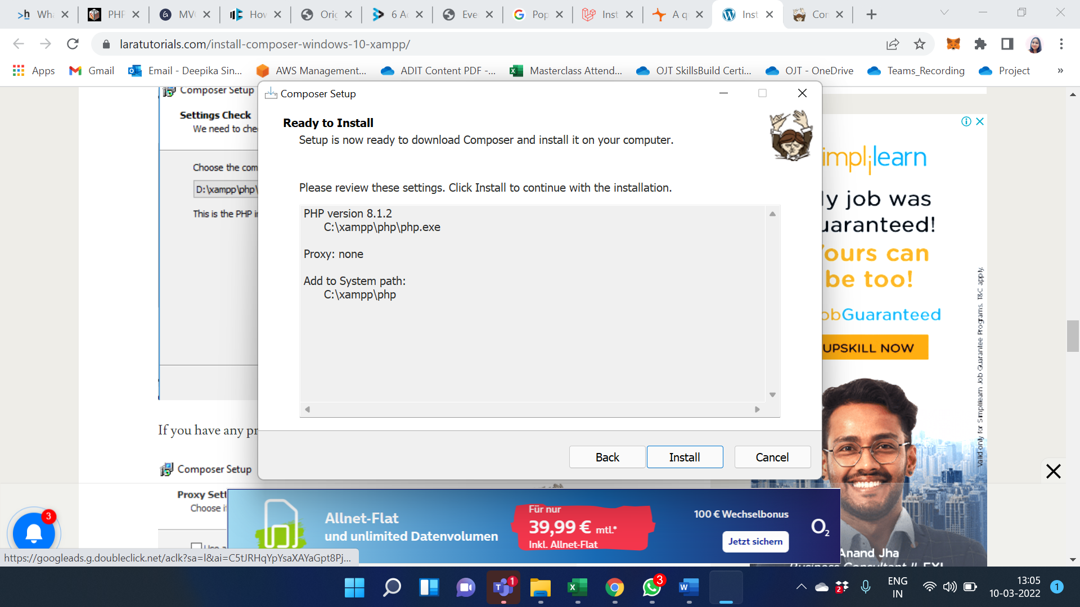

Composer has been installed successfully. Click to finish button.

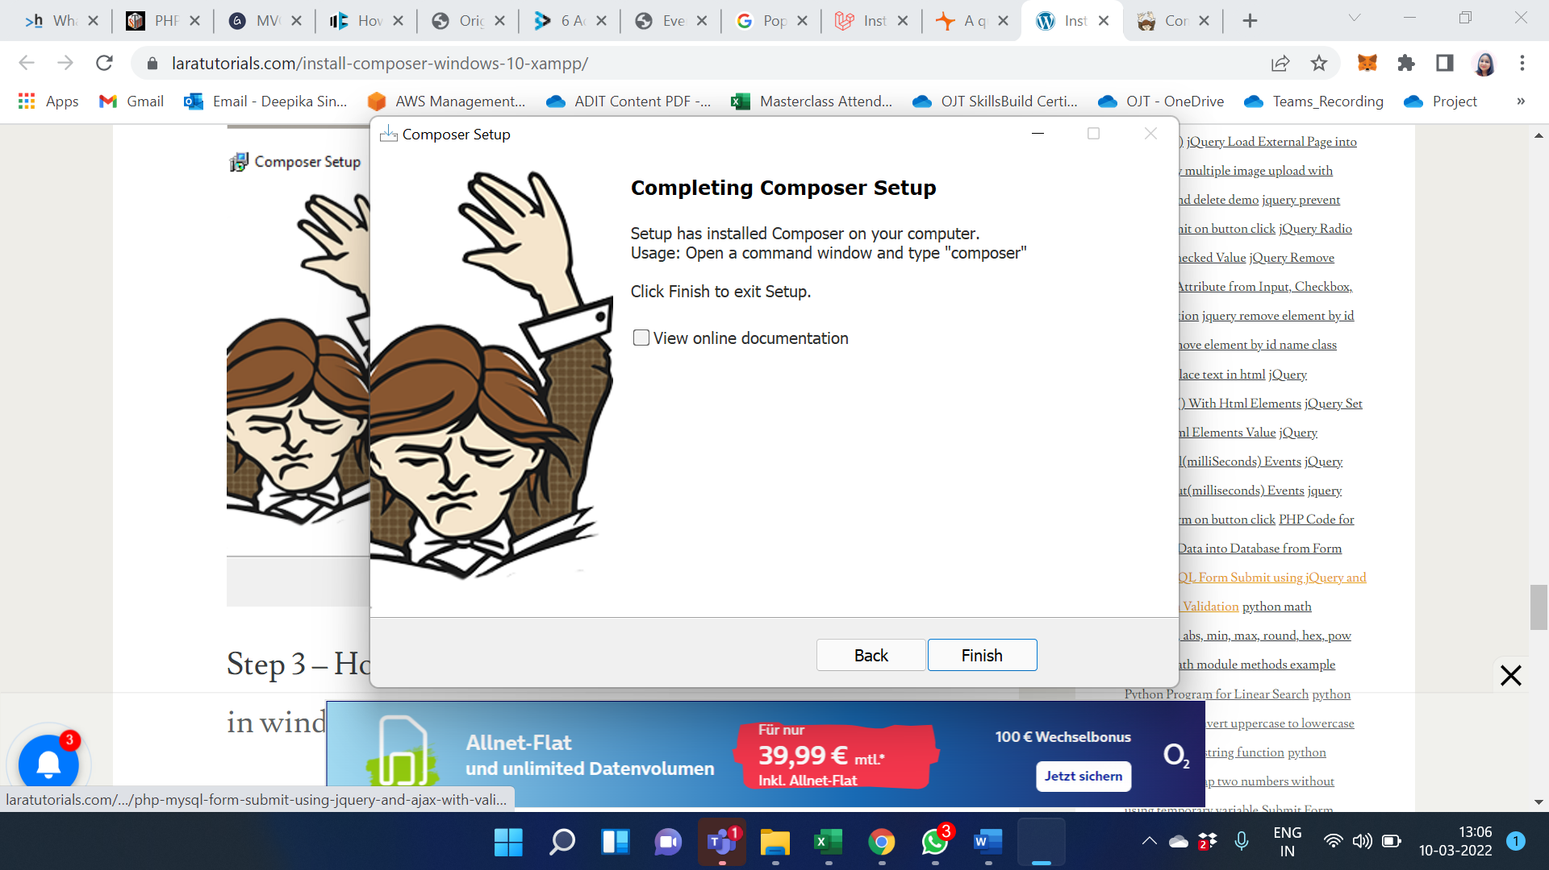

#### Step 3 – How to check composer is installed or not in windows

Now, open your terminal and type the following command on command prompt:

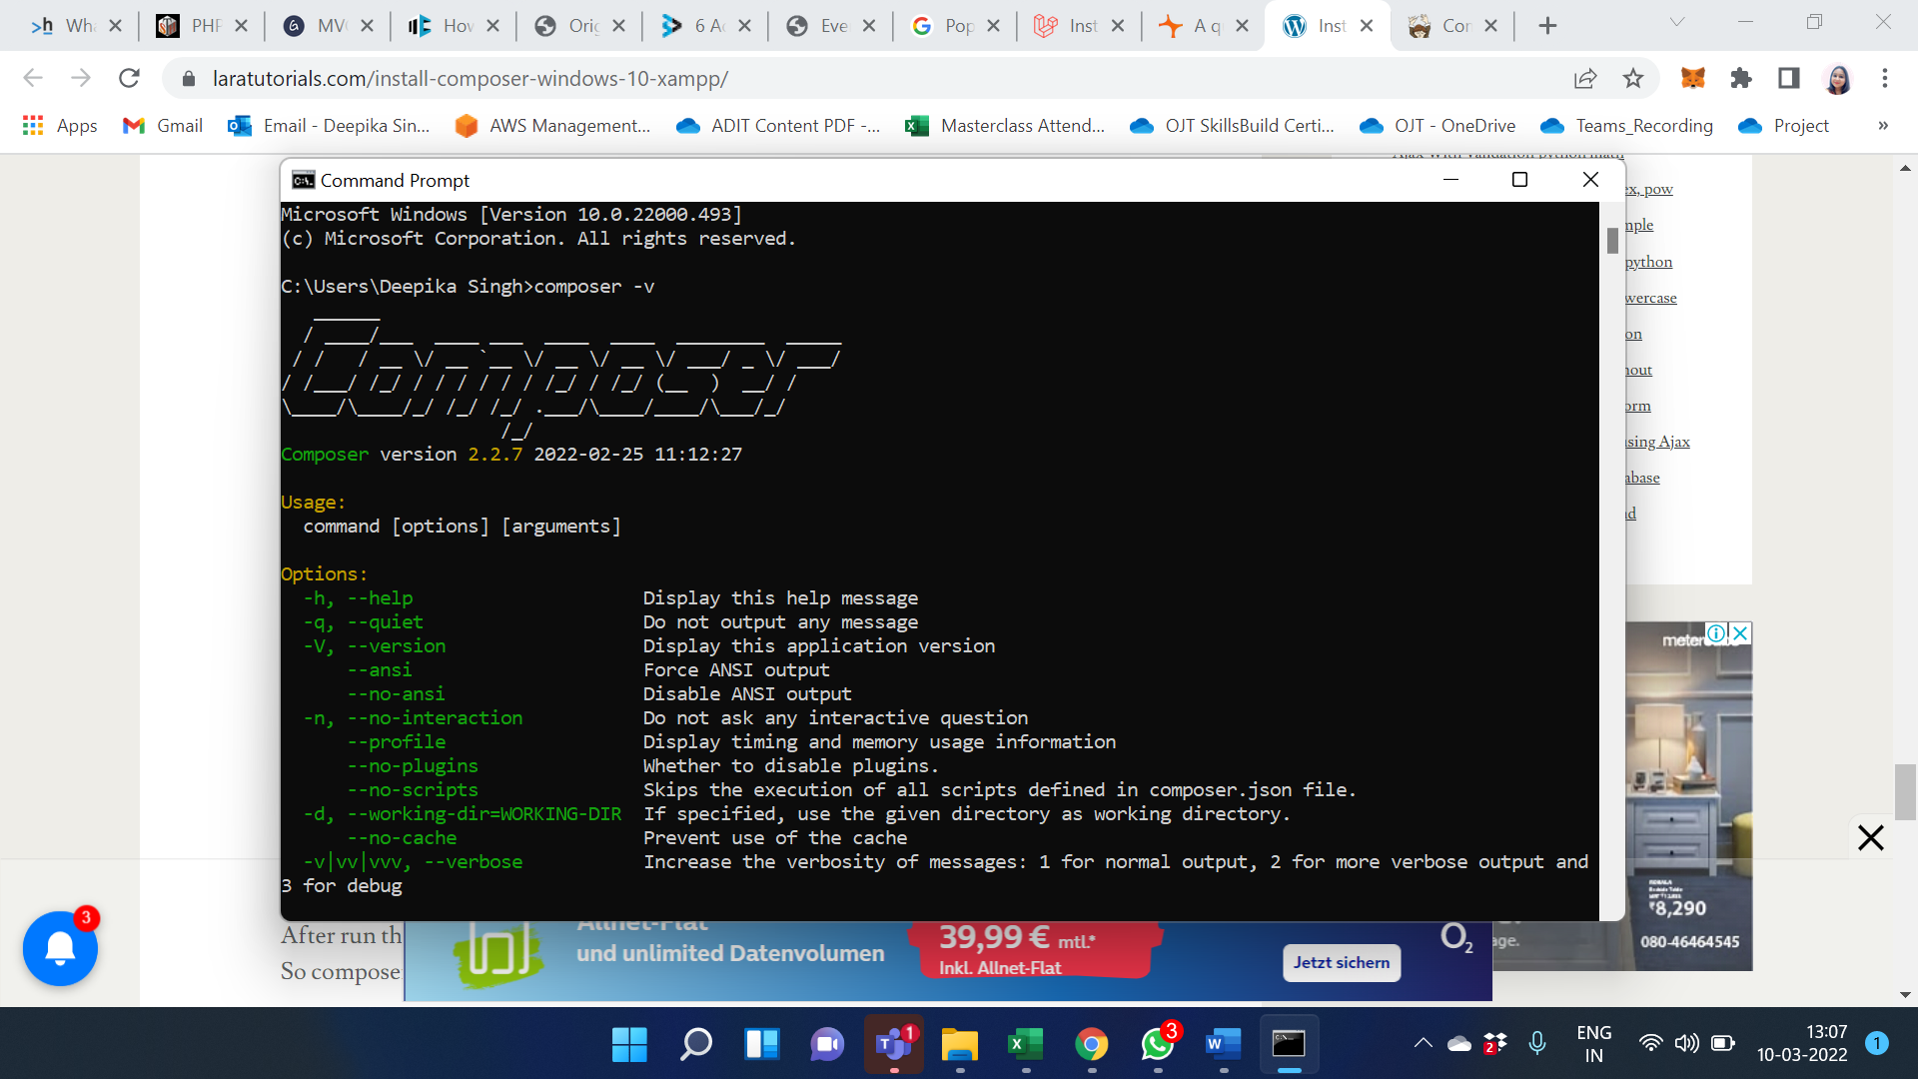

After run the above command on cmd. If You will look like the image given below. So composer successfully installed on your windows 10 xampp.

### Check the server requirement for the setup:

* PHP >= 7.3
* BCMath PHP Extension
* Ctype PHP Extension
* Fileinfo PHP extension
* JSON PHP Extension
* Mbstring PHP Extension
* OpenSSL PHP Extension
* PDO PHP Extension
* Tokenizer PHP Extension
* XML PHP Extension.

### Installing Laravel:

Type the following command in your command prompt window:

* composer global require “laravel/installer”.
* composer create-project –prefer-dist laravel/laravel Project_name: this command will install Laravel and other dependencies with it also generate the ANSI key.

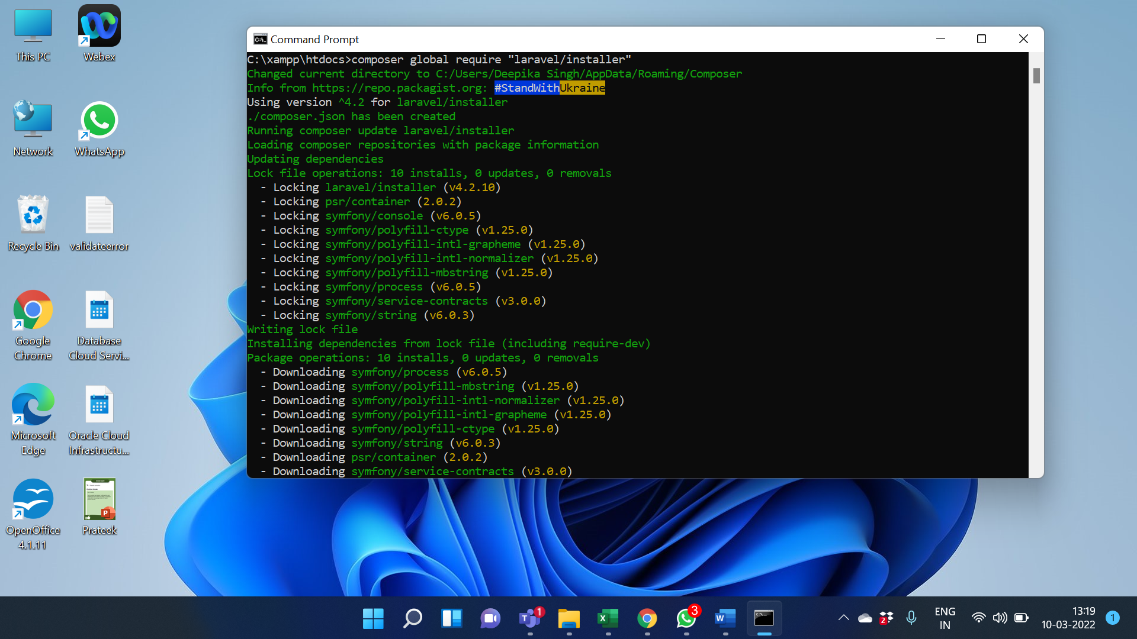

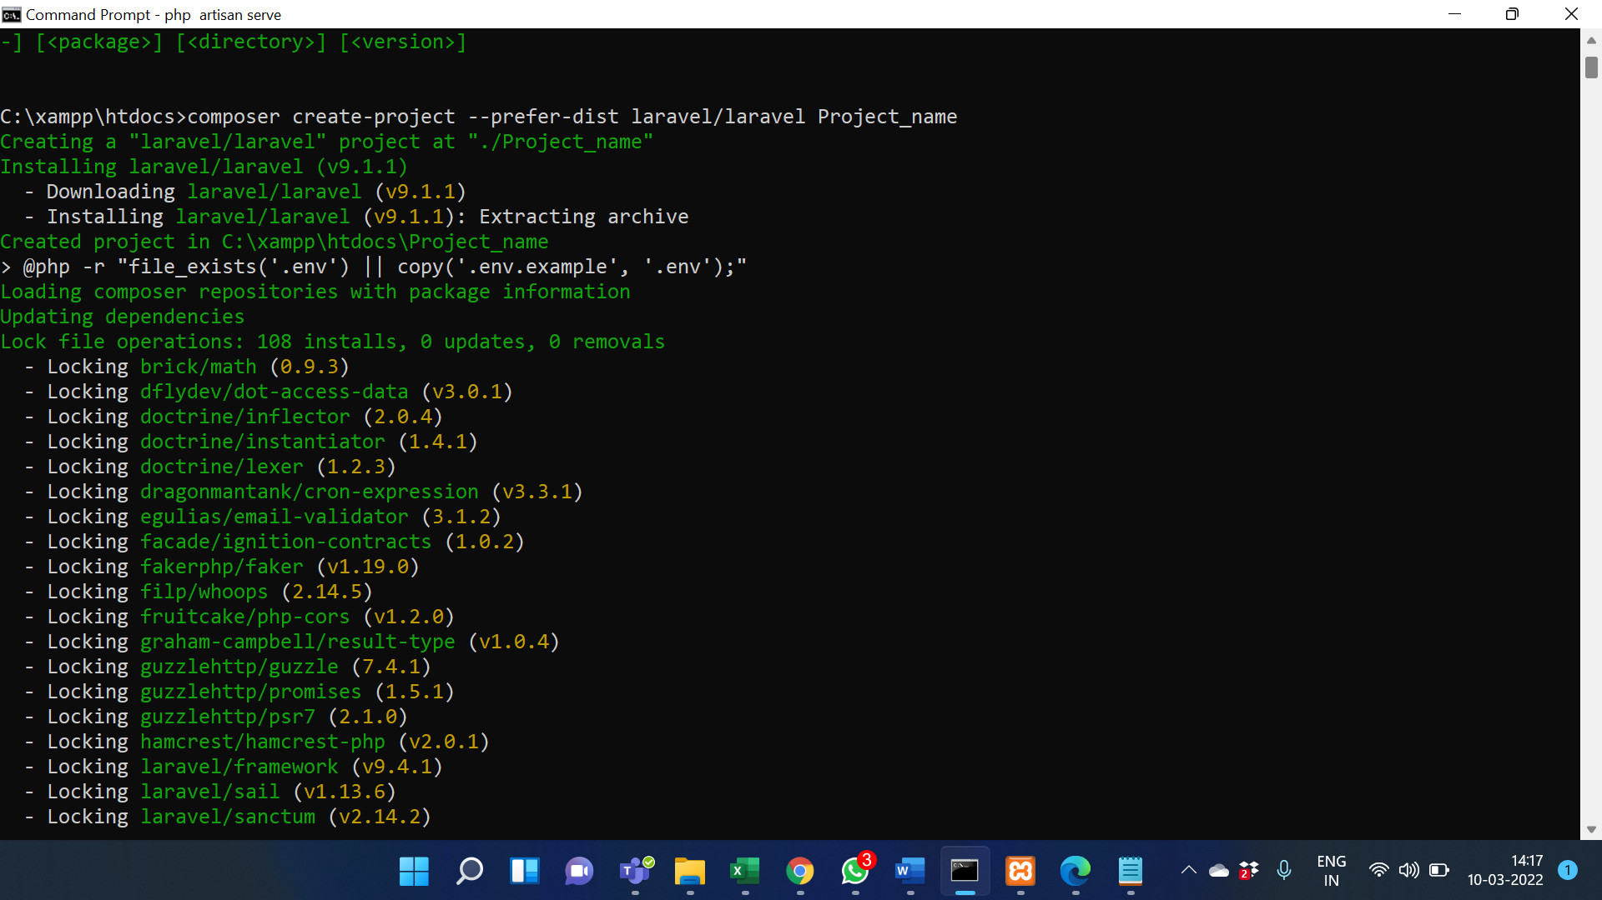

### Create Database for Project

* Go to phpMyAdmin click on create a new tab.
* Name the database.
* Press create button.

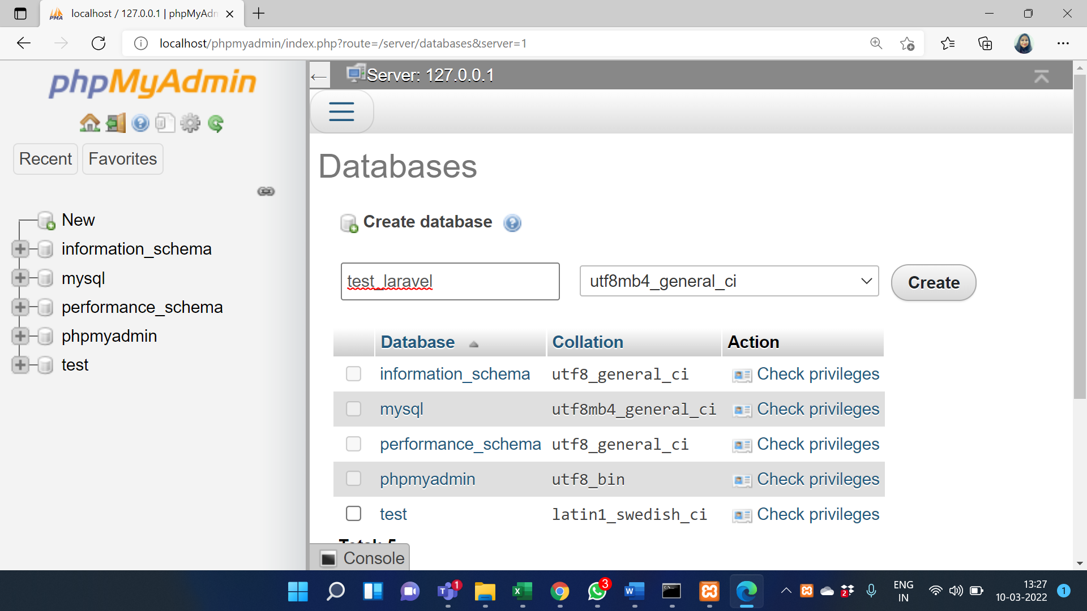

Update .Env file:

* APP_NAME=first_laravel
* APP_ENV=local
* APP_KEY=base64:TJ9Sob7KFPhL5XkqT+TyQux3x7UbW08QLb0xtirLWSs=
* APP_DEBUG=true
* APP_URL=http://127.0.0.1:8000
* LOG_CHANNEL=stack
* LOG_LEVEL=debug
* DB_CONNECTION=mysql
* DB_HOST=127.0.0.1
* DB_PORT=3306
* DB_DATABASE=test_laravel
* DB_USERNAME=root
* DB_PASSWORD=

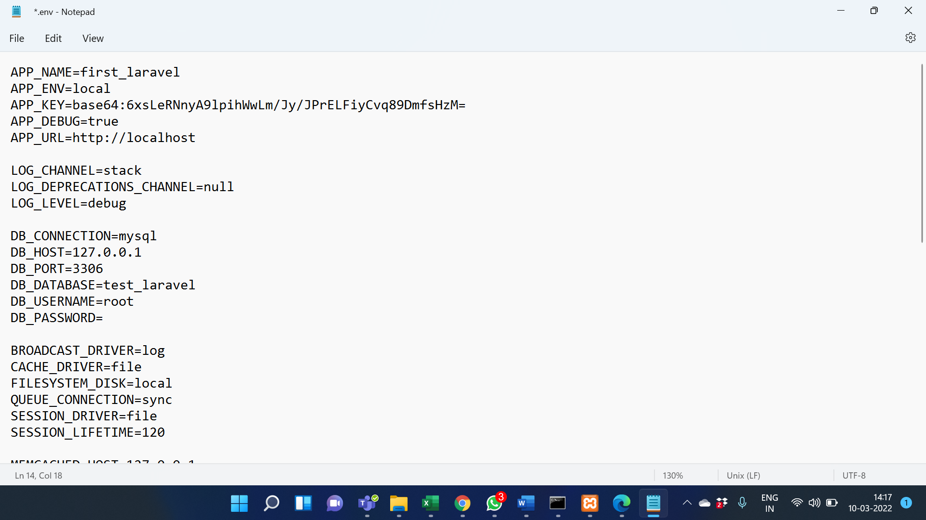

### Migrate database:

Create tables in the database for Laravel access, also helps in database version control following are the commands for migration.

PHP artisan make migration create_databse_table: this command is used to create the DB migration file in your ‘database/migration’ folder.

PHP artisan migrate: used to run the pending migration changes to the database

### Start development server:

PHP artisan serve: this command starts your development server.

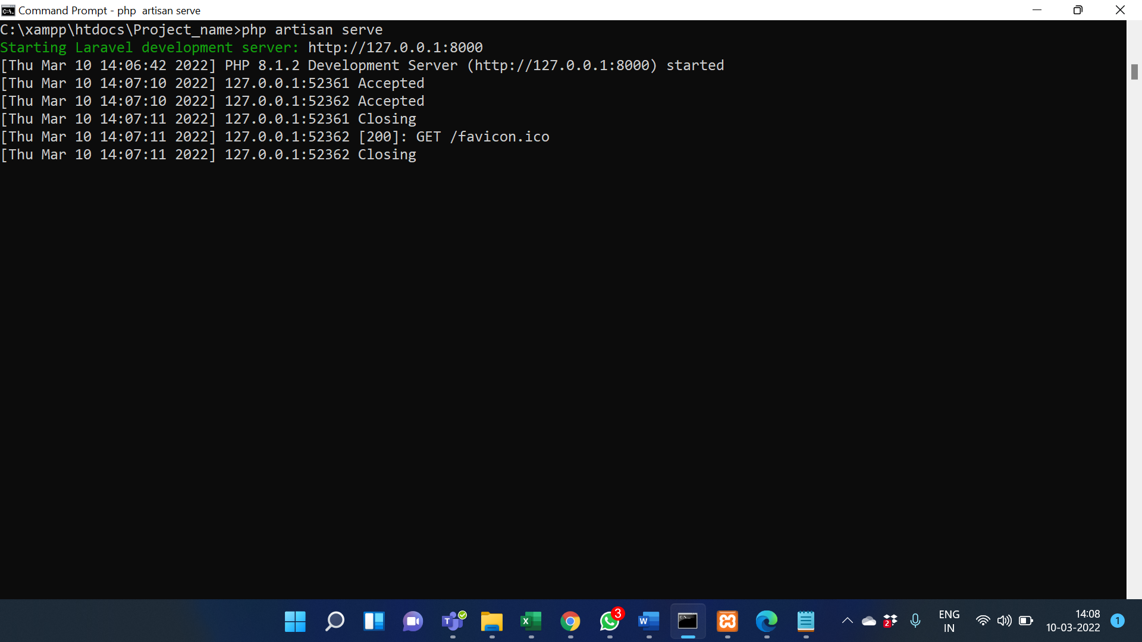

### Go to the IP URL that you see on your CMD screen.

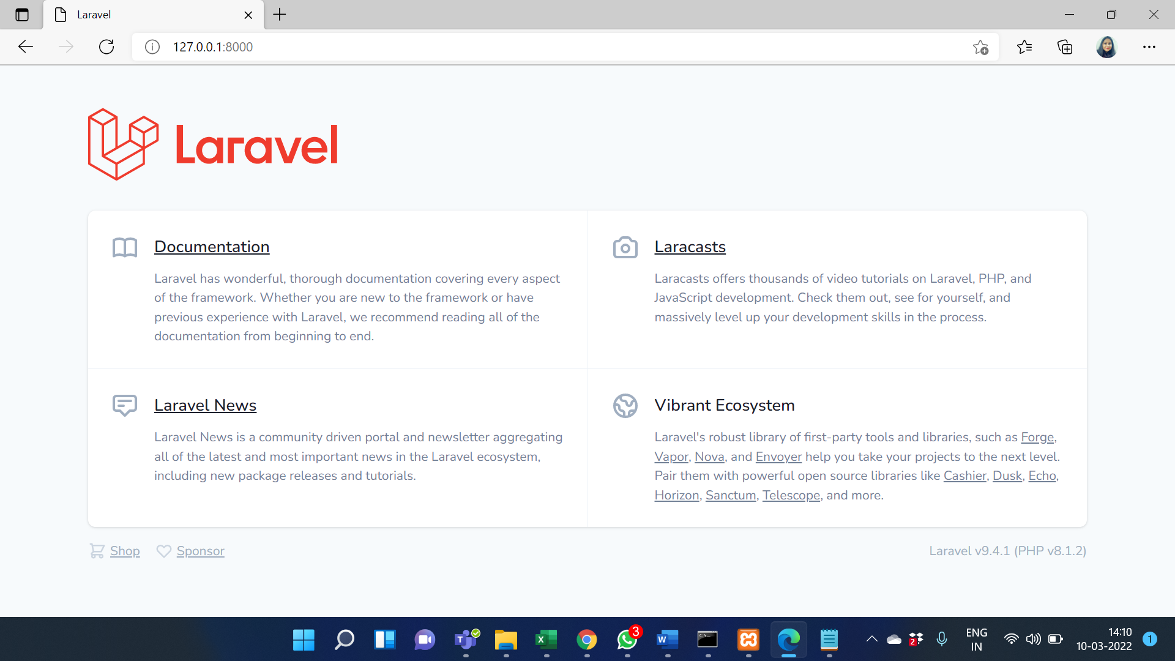

## Laravel PHP Project Structure

The project structure consists of directories, sub-directories, and files.

Open your project from the File Explorer to see the root directory structure of the Laravel project. You will see a screen similar to below.

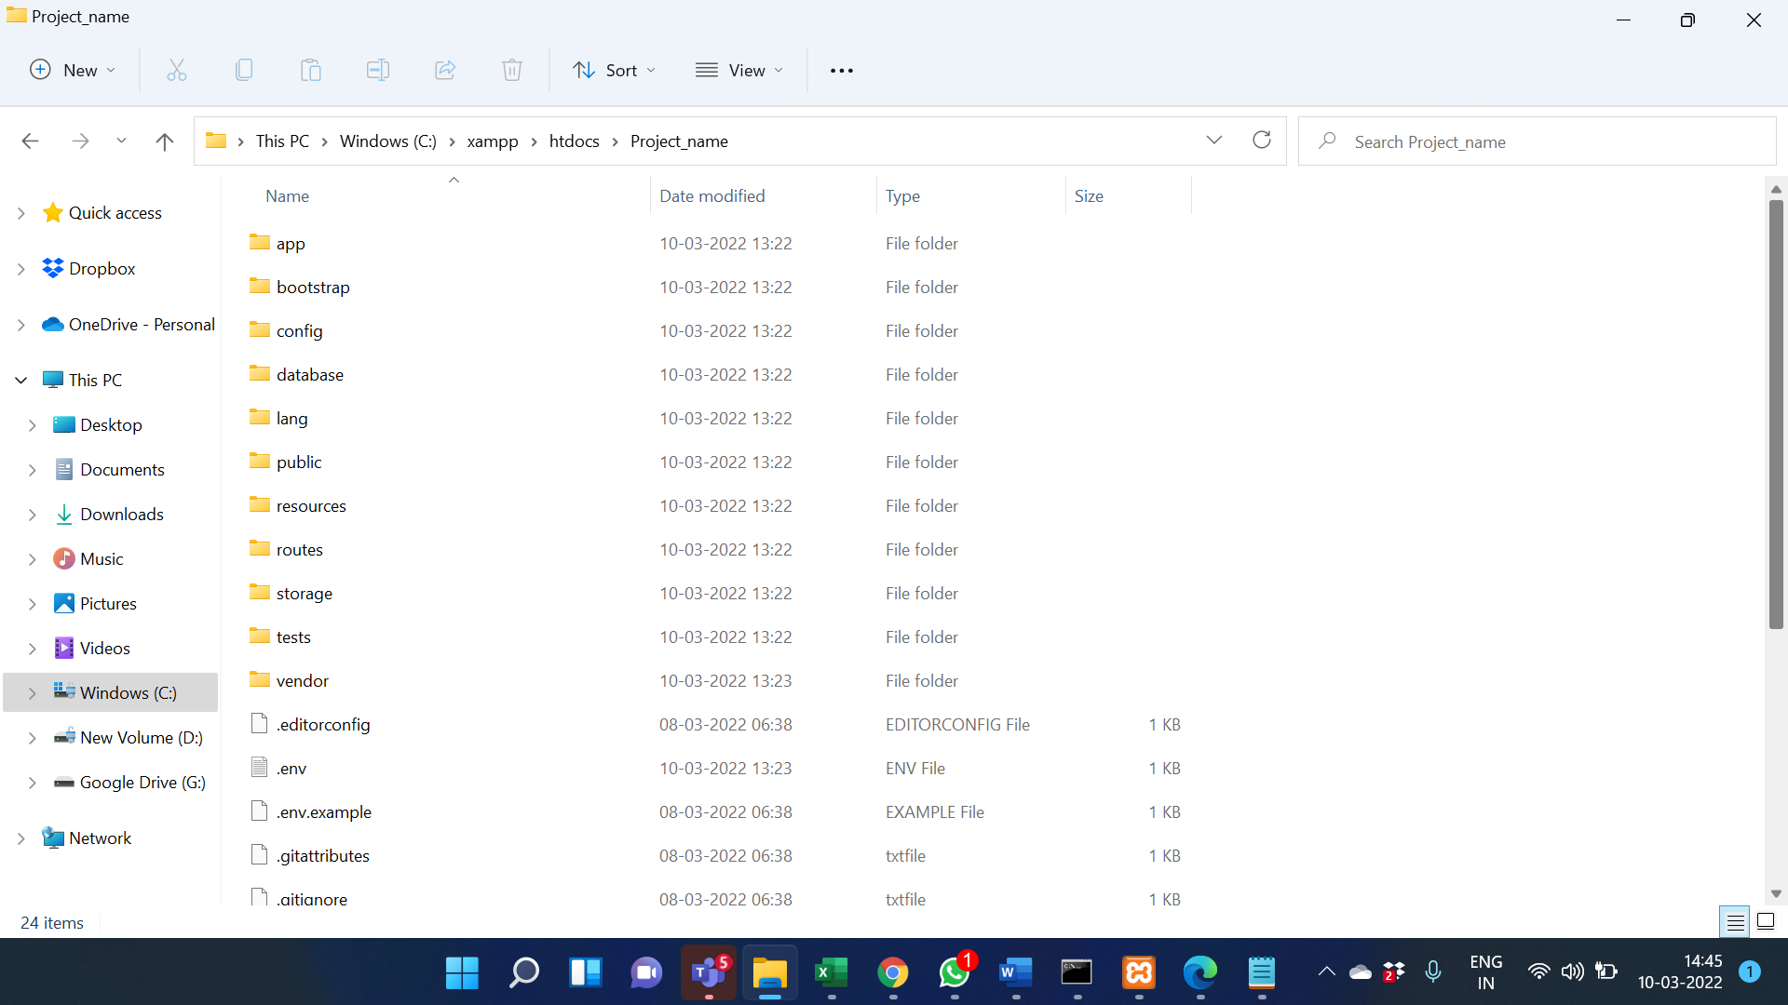

The following list describes some important directories, sub-directories, and files in a typical Laravel project:

* **app directory**: This directory is one of the most important directories in the root. The app directory contains the source code of the web application. It includes the following sub-directories and the **User.php** file.
  + **Console directory**: This directory contains artisan commands required for Laravel.
  + **Exceptions directory**: This directory contains exception handlers.
  + **Http directory**: This directory contains sub-directories for Controllers and Middleware.
  + **Providers directory**: This directory contains all the service providers.
  + **User.php file**: This is the default Model provided by Laravel.
* **bootstrap directory**: This directory contains files related to bootstrap the Laravel PHP application.
* **config directory**: This directory contains various configuration files required for the Laravel PHP application.
* **database directory**: This directory contains files related to the database. It includes the following sub-directories and the .gitignore file.
  + **factories directory**: This directory generates many data records.
  + **migrations directory**: This directory contains files related to database migrations.
  + **seeds directory**: This directory contains classes used for the unit testing database.
* **public directory**: This directory contains files that help to initialize the Laravel PHP application.
* **resources directory**: This directory contains HTML files, CSS files, JavaScript files, and blade templates. It includes the following sub-directories.
  + **js directory**: This directory contains files related to JavaScript.
  + **lang directory**: This directory contains files for localization and internalization.
  + **saas directory**: This directory contains files such as SCSS files.
  + **views directory**: This directory contains HTML files or templates which help to display data to the user.
* **routes directory**: This directory contains all the routes definitions for the Laravel PHP application.
* **storage directory**: This directory contains cache files, session files, etc.
* **tests directory**: This directory contains test files such as unit test files.
* **vendor directory**: This directory contains all the composer dependency packages.
* **.env file**: This file includes environmental variables.
* **composer.json file**: This file is a configuration file that specifies dependencies.
* **package.json file**: This file is similar to the composer.json file but it is for the frontend and few more files

## Introduction To Laravel Routes

Routing accepts the request and redirects it to the relevant controller function.

There are two main route files in the Laravel Framework:

* routes/web.php: This file is used to register web routes.
* routes/api.php: This file is used to register API routes.

The following code segment shows the default web route registered by Laravel to display the welcome page.

Route::get('/', function () {

return view('welcome');

});

In the above route, Route is the class used to define the function get(). The function get() has a parameter “/” which indicates the root URL of the Laravel application.

The following command can be run in the command prompt to get the full list of registered routes.

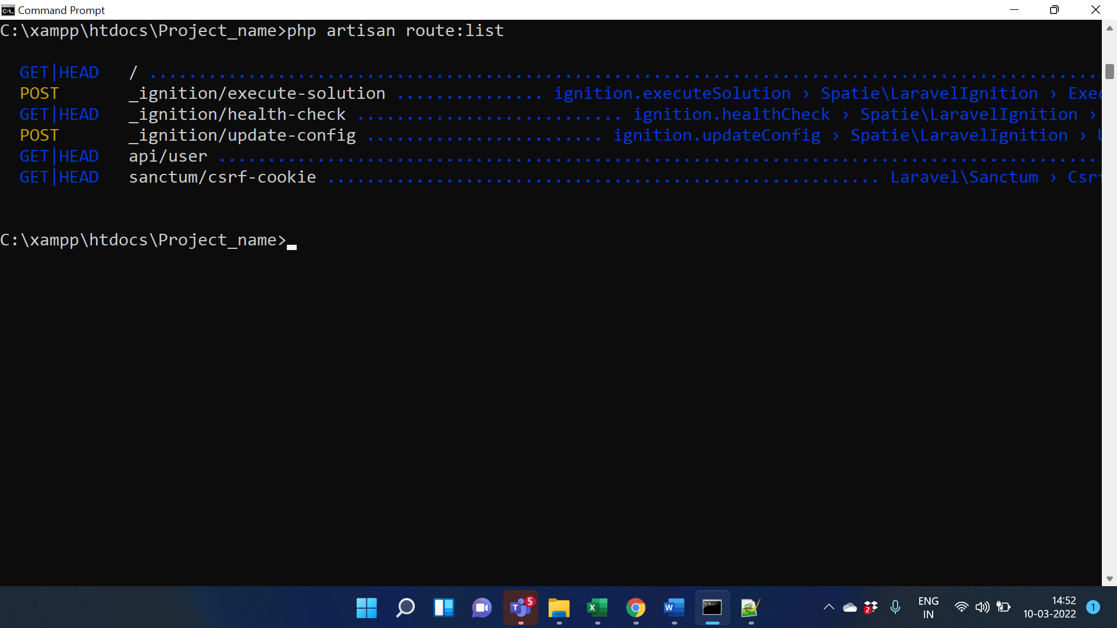

### Creating a Route

#### Step 1:

Add the following code segment in routes/web.php file to register a new route.

Route::get('/example', function () {

return "Hello World!!";

});

#### Step 2:

Visit the URL: http://127.0.0.1:8000/example to see the output.

#### Step 3:

The following screenshot shows the output.

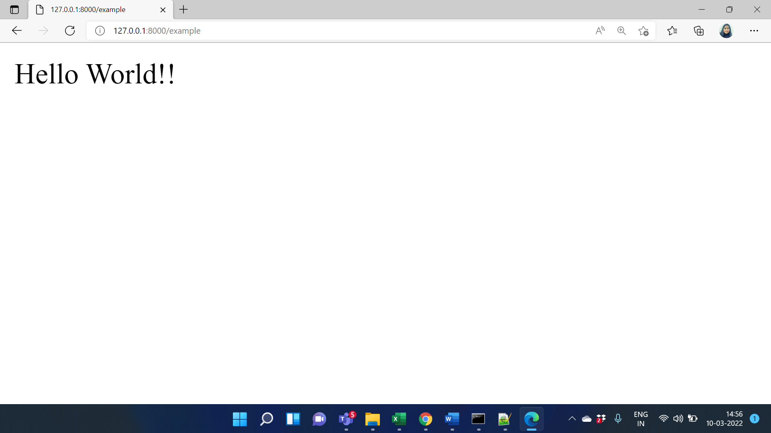

## What Is Middleware

In simple words, middleware is a bridge between a request and a response. It provides a mechanism to filter HTTP requests.

All the middleware files are stored in the app/Http/Middleware directory.

The Laravel Framework has a middleware to check whether the user of the Laravel application is authenticated or not. If the user is authenticated, it directs to the home page and if the user is not authenticated, it redirects to the login page.

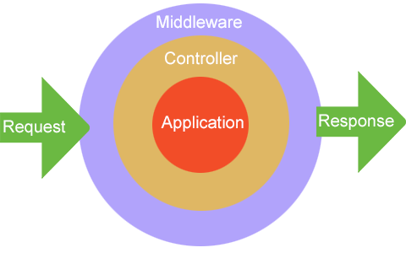

Image : What is Middleware

Reference: <https://w3programmers.com/bangla/wp-content/uploads/2017/12/Middleware2.png>

## Introduction To Terminable Middleware

Run the following command in the command prompt to create a terminable middleware named TerminateMiddleware.

php artisan make:middleware TerminateMiddleware

This command will create a file named TerminateMiddleware.php in the app/Http/Middleware directory.

Terminable middleware works right after any response sent to the browser.

## Introduction To Views

In MVC architecture, the character ‘V’ stands for View. Views contain HTML, CSS and JavaScript. The Views represent the frontend of the Laravel application, and it is used to display the content for the user.

All the views are stored in the resources/views directory. By default, the Laravel Framework provides the welcome.blade.php file.

### Creating a View

#### Step 1:

Create a view named index.php in the resources/views directory and save the following code.

<!DOCTYPE html>

<html lang="en">

<body>

<h1>Hello World!</h1>

</body>

</html>

#### Step 2:

Add the following code segment in the routes/web.php file to register a new route.

Route::get('/index', function () {

return view('index');

});

#### Step 3:

Visit the URL: http://127.0.0.1:8000/index to see the output.

#### Step 4:

The following screenshot shows the output.

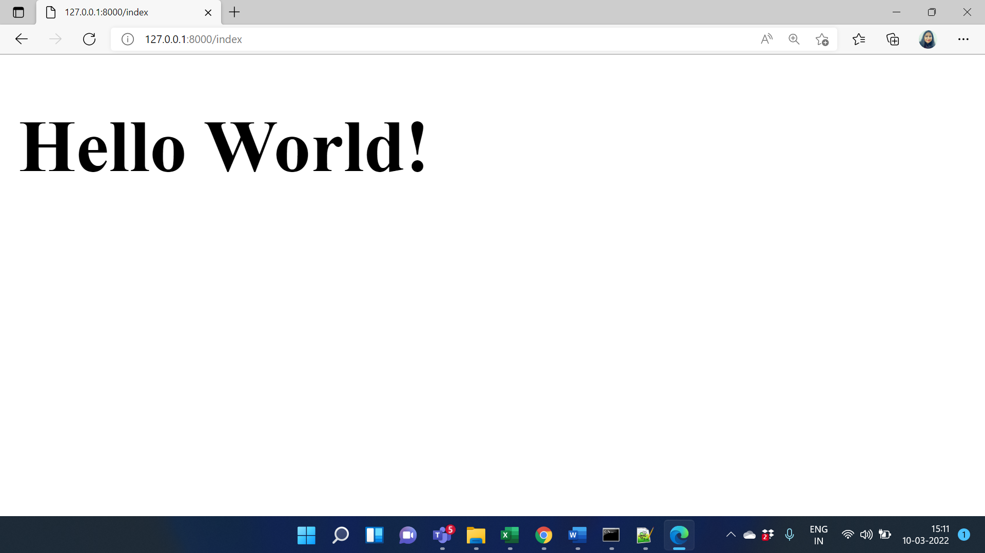

### Passing Data to Views

Let’s do an example to see how data can be passed to the view.

#### Step 1:

Create a view named user.php in the resources/views directory and save the following code.

<!DOCTYPE html>

<html lang="en">

<body>

<?php echo 'My name is '.$name ?>

</body>

</html>

#### Step 2:

Add the following code segment in the routes/web.php file to register a new route.

Route::get('/user', function () {

return view('user',['name'=>'Srishti']);

});

#### Step 3:

Visit the URL: http://127.0.0.1:8000/user to see the output.

#### Step 4:

The following screenshot shows the output.

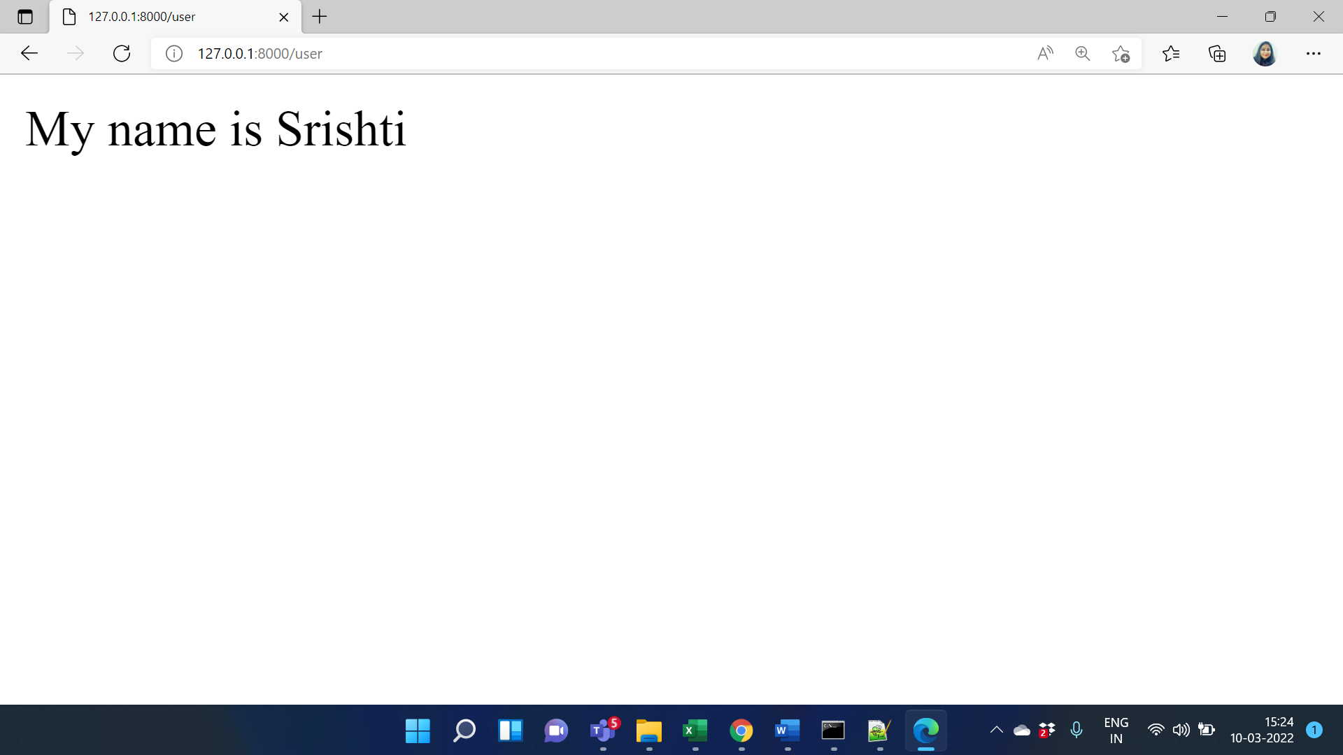

# Blade templating engine in laravel

Blade templates use .blade.php extension. The blade templates stored in the resources/views directory.

## Usage of Blade Templates

### Usage 1: variable values

In blade templates, we can use {{ $variable }} to print the value of a variable instead of <?php echo $variable ?> As you see, there is no need to write PHP tags or the echo keyword.

Let’s do an example!

Earlier, we created the user.php file using the following code.

<!DOCTYPE html>

<html lang="en">

<body>

<?php echo 'My name is '.$name ?>

</body>

</html>

#### Step 1:

Rename the file user.php to user.blade.php (in the resources/views directory) and modify the existing code as shown below.

<!DOCTYPE html>

<html lang="en">

<body>

<p>Hi, My name is {{$name }}</p>

</body>

</html>

#### Step 2:

Visit the URL: http://127.0.0.1:8000/user.

#### Step 3:

The following screenshot shows the output.

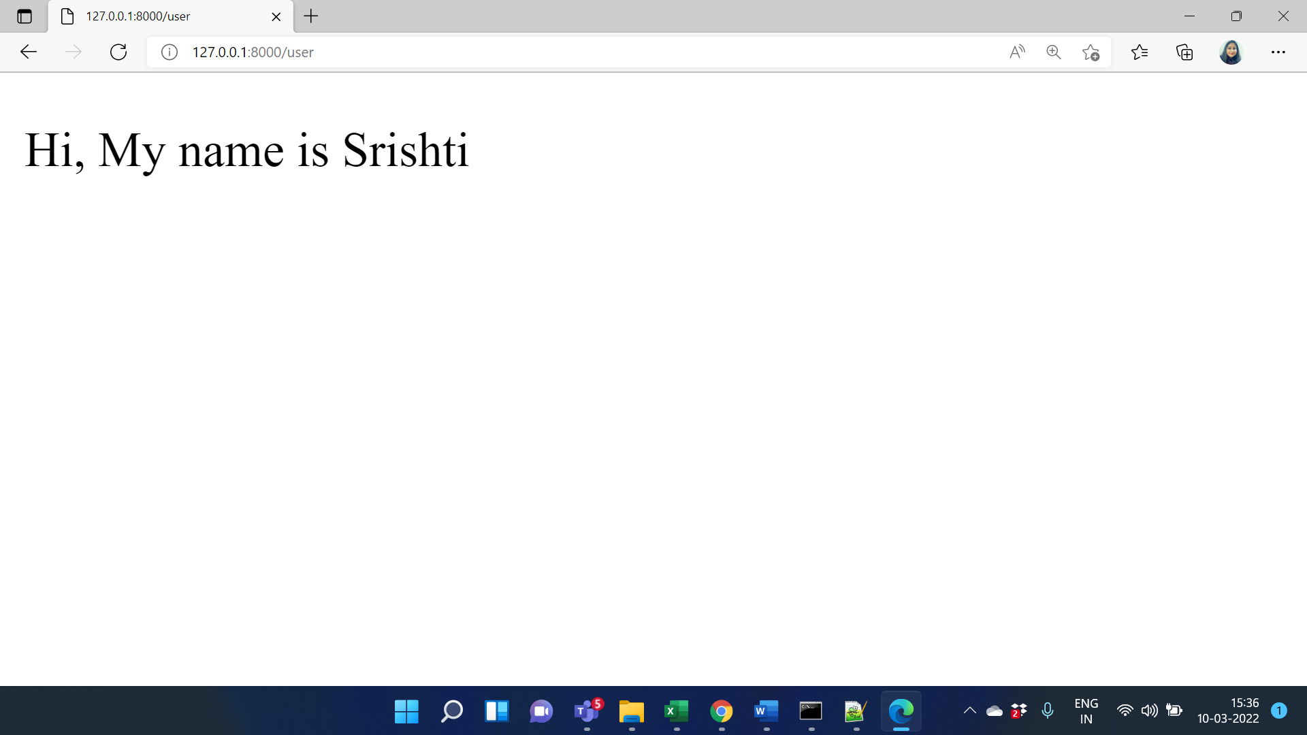

### Usage 2: ternary operators

In blade templates, we can use {{ $variable or ‘default_value’ }} instead of <?phpisset($variable) ? $variable : ?default_value? ?> to write ternary operators.

References

1. <https://www.tutorialspoint.com/struts_2/basic_mvc_architecture.htm>
2. <https://www.guru99.com/mvc-tutorial.html>
3. <https://erpsolutions.oodles.io/blog/web-development-frameworks-benefits/>
4. <https://www.csharpens.com/articles/what-is-net-framework-uses-and-benefits-1035/>
5. <https://www.vivantatechnologies.com/advantages-of-using-framework>
6. <https://laravel.com/docs/5.1/structure>
7. <https://blog.pusher.com/laravel-mvc-use/>
8. <https://selftaughtcoders.com/from-idea-to-launch/lesson-17/laravel-5-mvc-application-in-10-minutes/>
9. <https://laravel.com/>
10. <https://dev.to/grahammorby/mvc-and-creating-it-in-laravel-8-2a6b>
11. <https://www.linkedin.com/pulse/advantages-php-mvc-framework-why-laravel-become-most-2017-hardik>